Snoopy Halloween Door Decs

Brandon Douglas, RA
Albion College

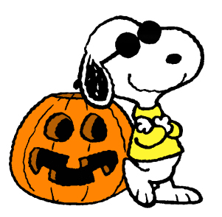
Insert Name Here
Insert Name Here

