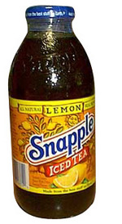
#1) Fact or Fiction: A Bottle of Snapple contains more caffeine than a can of Pepsi.

Fact
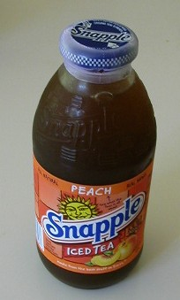
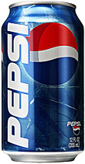
A 16 oz bottle of a Snapple drink contains 42 mg of caffeine, which is more than the 38 mg of caffeine found in a 12 oz can of Pepsi.

>
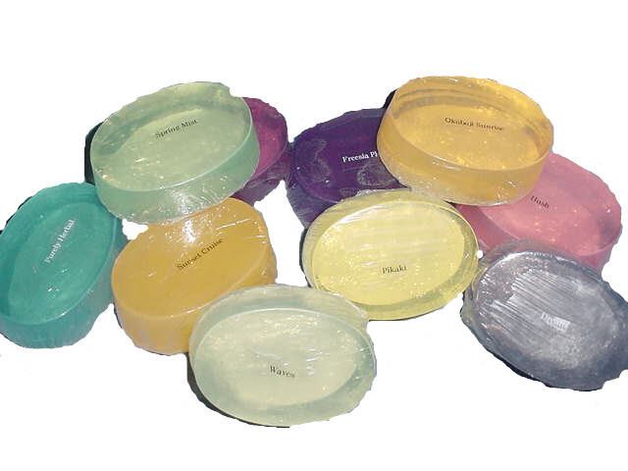
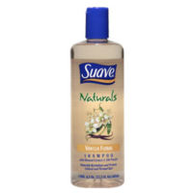
#2) Fact or Fiction: Caffeine cannot be found in shower products like soap and shampoo.

Fiction

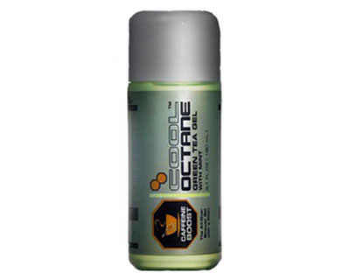
Recently, manufacturers of shower products have been putting caffeine in soaps, shampoos, and other shower products. An example is the Octane Caffeinated Shower Gel, pictured.
The purpose is to provide the stimulating effects of caffeine through entering the skin and hair.

#3) Fact or Fiction: A decaffeinated beverage contains absolutely no caffeine.

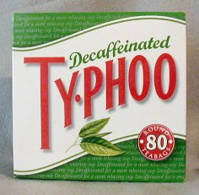


Fiction

No matter what, you are not completely avoiding caffeine when drinking a decaffeinated beverage. According to one research, 10 cups of decaffeinated coffee contains as much caffeine as 2 cups of regular coffee.


#4) Consuming over 350 mg of caffeine a day is considered excessive.


Fiction
Moderate caffeine consumption is often defined as 300 mg – 400 mg a day, which is equivalent to about 3 – 4 cups of coffee. By consuming this much a day, it poses little health risks and actually some health benefits. Consuming over 500 mg of caffeine daily is considered excessive.



#5) Fact or Fiction? Caffeine can help improve your memory.

Fact
Caffeine has been proven to improve a person’s short-termed memory. It boosts activity in brain regions related to attention and short-term memory.
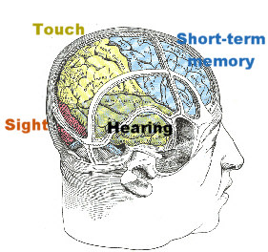

#6) Fact or Fiction? Coffee consumption can prevent the risk of colon cancer.

Fact

Many studies have concluded that those who drink coffee regularly reduce their risk of colon cancer approximately 25 %. Further studies have shown that coffee drinking can reduce one’s risk of Parkinson’s disease (ironically), type 2 diabetes, and liver cancer.

#7) Fact or Fiction? Caffeine addiction is easy to eliminate: It leads to no withdrawal symptoms.

Fiction
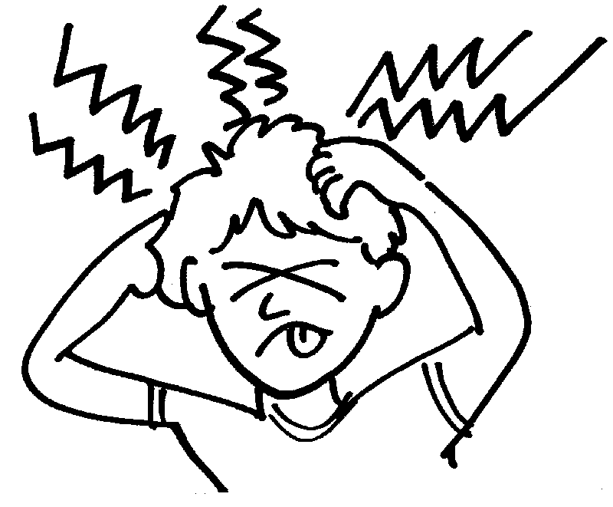
Quitting caffeine is not the easiest thing to do. It can lead to withdrawal symptoms such as headache, fatigue, drowsiness, irritability, difficulty in concentrating, nausea, and muscle stiffness. The best way to lower caffeine addiction is to decrease the daily intake over a long period of time rather than to do it quickly.

#8) Fact or Fiction? Caffeine should not be consumed during pregnancy because it can lead to premature and unhealthy birth.

Fiction

Studies have shown that there is no greater risk of premature birth and underweight babies when moderately consuming caffeine during pregnancy. Furthermore, a Danish study found out that amongst a group of pregnant women who took caffeine and another group who did not take caffeine, there were no differences either the length of pregnancy or birth.

#9) Fact or Fiction? Caffeine addiction can directly lead to heart disease.


Fiction
Caffeine does boost one’s blood pressure temporarily, but alone does not increase one’s risk for heart disease. However, the fact that caffeine does boost blood pressure in conjunction to increased daily stress levels can lead to an increased risk of heart disease.

#10) Fact or Fiction? Caffeine improves on your concentration.


Fact
Caffeine is a stimulant that directly affects the Central Nervous System (CNS). It makes you more alert and speeds up your reaction times, thus making you more able to concentrate more. Additionally, many studies have shown that caffeine makes you more persuasive and more likely to change your mind over certain situations.

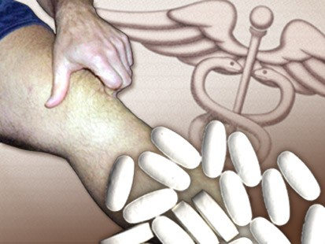
#11) Fact or Fiction? Caffeine can help ease workout pain.

Fact
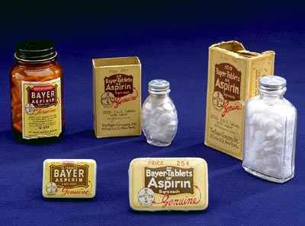
Researchers have discovered that consuming caffeine equivalent to two cups of coffee can reduce post-workout muscle pain by as much as 50%. In fact, it does a better job of relieving muscle pain than pain-reduction medications like aspirin or ibuprofen.


#12) Fact or Fiction? Caffeine in a chocolate bar has very little effect on a person’s body.


Fact
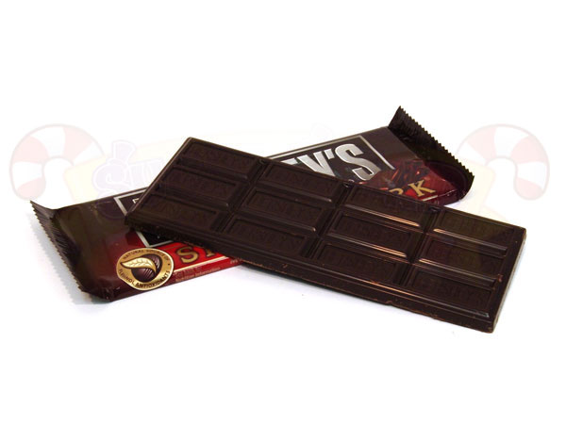
A typical 28 gram milk chocolate bar has as much caffeine as a cup of decaffeinated coffee. More specifically, a Hershey’s Special Dark Chocolate bar contains only 31 mg of caffeine, by far too little to have any effect.

Submitted
By:
Anthony Bartens
Resident Advisor
U.H.S., Cal Poly Pomona

